Name of Event: Community led planning process for conservation & management of forest and livelihood
Date: 25th & 26th September, 2022
Venue: Forest Training School, Mahilong, Ranchi
A two-day state level workshop on “Community led planning process for conservation and management of forest resource and livelihood” was organized at State Forest Training School, Mahilong, Ranchi.
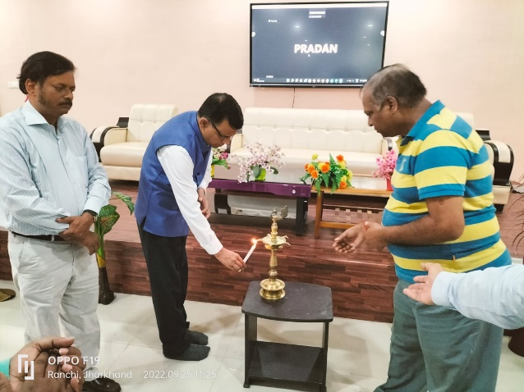
The workshop witnessed the presence of Mr. H.S. Gupta, Former PCCF, IFS as the Chief Guest who inaugurated the workshop by lighting the lamp. He was accompanied by Mr. S. Tripathy, IFS and Mr. V.S. Dubey, IFS on the dice. After a small introduction by 100 participants, the welcome session was addressed by Mr. Dubey.
The workshop mainly focused on the fact that participants shall develop an enhanced understanding of the community forest resource conservation and management planning process in the context of FRA and prepare action plan and strategy for Community Forest Resource Conservation and Management Planning Process (CFRCMP).
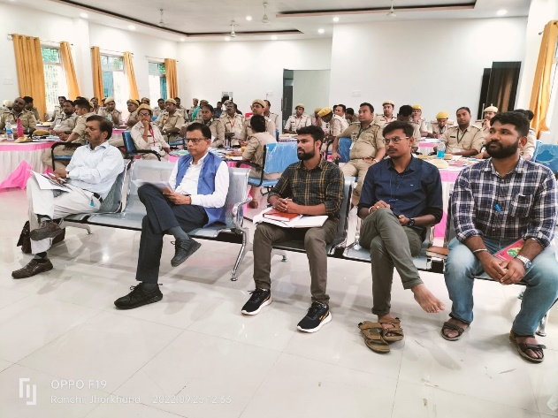
Mr. Soumik Banerjee an eminent person presented a PPT on role of forest and the life and livelihood of Adivasis and other forest dwelling communities and importance of CFRCMP. He presented a startling fact that in today’s time an area of 27 football fields of forest is being lost per minute. He also stressed on the role and importance of forest in our lives and how its depletion is an unseen treat in present times. The chief guest, Mr. Gupta shared about the provisions of FRA and the role of community and the Gram Sabha for CFR management and its plan. He also focused on integrating conservation of biodiversity with life and livelihood. A small movie was also shown on global forest scenario and how life of forest dwellers is meaningless without the sustainability of forests.
Mr. Tripathy highlighted on the association of Government and CSOs to provide better livelihoods to the communities. He also stressed on the fact of supporting each other for awareness generation. Mr. Ranjan shared his views on FRA and processes for claim making and CFRCMP, forest resources status mapping and assessment of current practices and planning tools.
Finally, an open plenary session was held jointly by participants in sub groups to explore the integration and develop execution mechanism and the role of the stakeholders. Consequently, an action plan was prepared where the required support and coordination was discussed.
The entire workshop was anchored by Mr. Prem Shankar and the vote of thanks was rendered by Anshika Singh from PRADAN.

